Duplicate File Manager

Problem Statement:
Large file collections often contain exact duplicates and near-duplicates (visually similar images/videos or audio copies with different encoding). This project implements a scalable tool to detect and help remove duplicates across mixed media (binary files, images/videos, audio) while minimizing false positives and leveraging parallel processing to handle large and deep directories.

Objectives:
- Detect strict binary duplicates using cryptographic hashing (SHA-256).
- Detect visual near-duplicates for images and videos using a perceptual image hash.
- Detect audio duplicates using audio fingerprinting.
- Scale across CPU cores or nodes by distributing work with OpenMPI.
- Provide a safe interactive workflow for users to review duplicate groups and move unwanted copies to a destination folder.

Methodology / Approach:
High-level flow
- File classification — each file is classified as binary, visual, or audio based on extension.
- Per-file processing — depending on type, the program computes:
  - SHA-256 for strict binary equality.
  - Perceptual visual hash (a 64-bit aHash derived from a resized grayscale frame) for images and a representative video frame.
  - Chromaprint audio fingerprint for audio streams after resampling to mono 44.1 kHz.
- Parallel scanning — the directory is traversed and files are assigned to MPI ranks in a round-robin fashion so each process computes hashes for a subset of files.
- Aggregation — each rank serializes its results into a byte buffer; the root rank gathers all buffers with MPI_Gatherv and reconstructs the global result set.
- Duplicate grouping and review — the root process groups:
  - Exact matches by SHA-256.
  - Audio matches by identical Chromaprint fingerprints.
  - Visual near-duplicates by converting stored hex hashes to 64-bit values and grouping items whose Hamming distance is small (threshold used in code: ≤ 3).
- Interactive resolution — for each duplicate group the user is shown the list and asked which file to keep; non-kept files are moved to a user-specified destination folder to operate on them / delete as per requirement.
Implementation notes
- The program uses OpenSSL EVP for SHA-256, OpenCV for image/video frame extraction and hashing, Chromaprint for audio fingerprints, and FFmpeg libraries (libavformat/libavcodec/libswresample) to decode audio streams.
- MPI is used for distribution and std::filesystem for traversal and file operations.
- The code prompts the user at runtime for the directory to scan and later for the destination folder to move selected duplicates.
cout << "\nEnter destination folder to move selected duplicates: ";
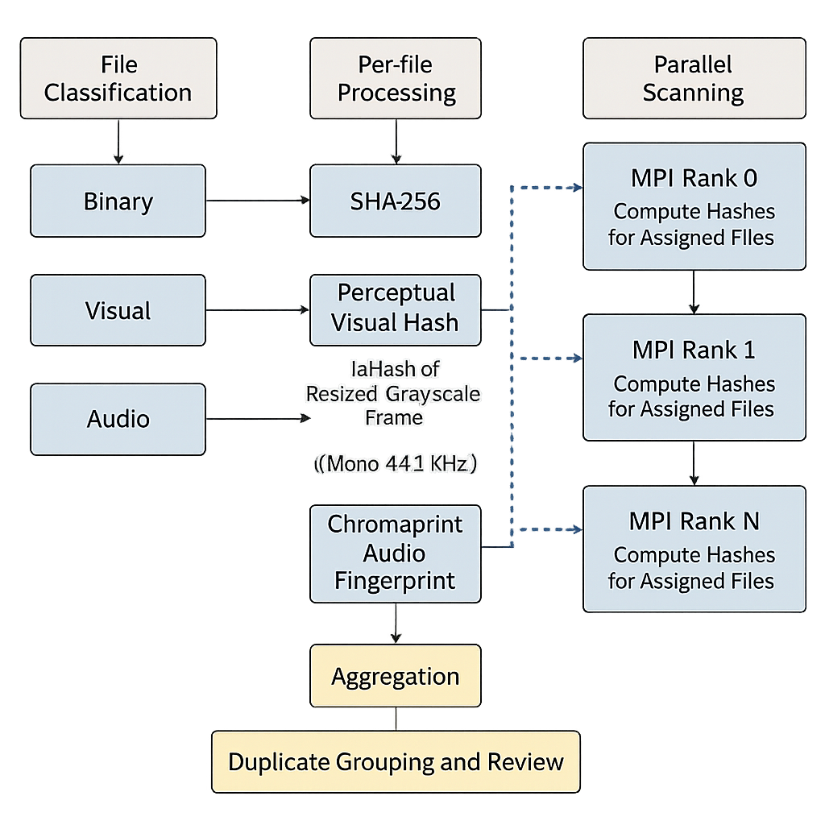

Work Completed So Far & Future Implementations:

Implemented Features
• Recursive filesystem traversal with permission handling
• MPI-based parallel workload distribution
• Strict duplicate detection using SHA-256 hashing (OpenSSL)
• Visual similarity detection using perceptual dHash (OpenCV)
• Audio similarity detection using Chromaprint + FFmpeg decoding
• Custom binary serialization and MPI_Gather/MPI_Gatherv aggregation
• Hamming distance computation for perceptual hash comparison
• Interactive duplicate review at root rank
• Safe relocation mechanism (rename with cross-device copy fallback)
• “Keep selected file” model to prevent accidental mass deletion
• Multi-format media handling (images, video frames, audio streams)

Yet to Be Implemented / Future Enhancements
• Undo/recovery log for restoration of moved files
• Performance benchmarking and scalability analysis
• Chunked MPI gathering for very large datasets
• Progress tracking during scan execution
• GUI or web-based interface integration
• AppImage or distributable packaging for deployment
• Optimization of audio fingerprint sampling window
• Persistent hash caching for incremental scans

